# 3D Printing Summary

|  |  |  |
| --- | --- | --- |
| **Metrics** | **Desk Stand** | **Bolt Stand** |
| Total Print Time (min) | 232 | 286 |
| Total Number of Components | 1 | 1 |
| Typical Total Mass (g) | 27 | 37 |
| Typical Number of Print Setups | 1 | 1 |

# 3D Printing Settings

|  |  |  |  |  |  |  |  |
| --- | --- | --- | --- | --- | --- | --- | --- |
| **Print File Name** | **Qty** | **Total Print Time (hr:min)** | **Mass (g)** | **Infill (%)** | **Support(Y/N)** | **Layer Height/ Nozzle Diameter(mm)** | **Notes (orientation, special settings, etc.)** |
| Desk_Stand.stl | 1 | 3:52 | 27 | 20 | N | 0.2/0.4 | * Print in default stl orientation |
| Bolt_Stand.stl | 1 | 4:46 | 37 | 20 | N | 0.2/0.4 | * Print in default stl orientation |

# Customization Options

* The device can be printed in any colour the user wants

# Post-Processing

* Use a hobby knife to remove any sharp edges.
* If using the bolt stand, insert ¼-20 t-nuts into the three slots in the Bolt stand as seen in the assembly guide.

# Examples of Quality Prints

**Photos of Desk Stand**

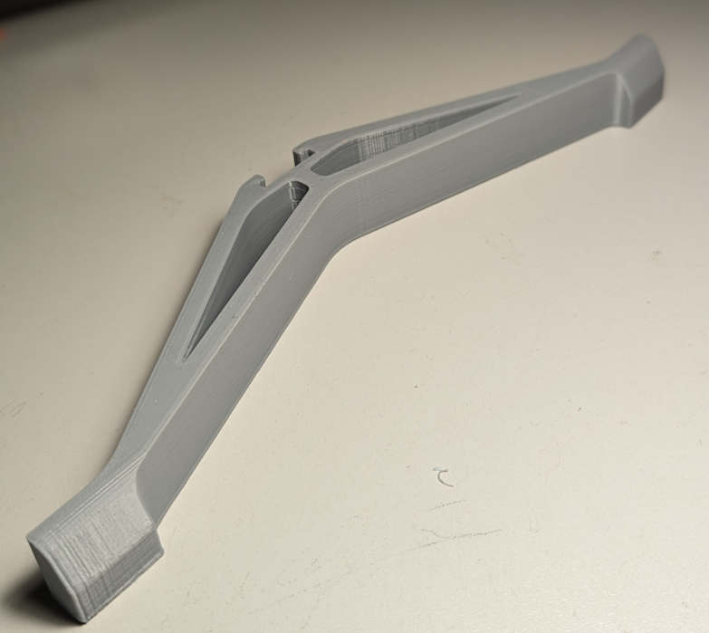

**Photos of Bolt Stand**

